EXPERIMENT 9: ***Individual Differences in Alpha Frequency Drive Crossmodal Illusory Perception, Cerere et al., 2015***

**Introduction**

* **Questions:** 
  1. Is individual alpha frequency peak ***correlated*** to the temporal window of the illusion? (***correlational approach***)
  2. Can tACS at different frequencies ***modulate*** the amplitude of the temporal window of the illusion? (***causal approach***)

To answer these two questions the experiment achieved two distinct results with two distinct procedures, respectively showing the *correlation* between alpha frequencies (1) and the integration time-window and the *causal relationship* (2) between the two

* *correlational approach* → manipulation of behavioural variable and observation of covariation of the studied physiological variable
* *causal approach* → manipulation of physiological variable and observation of its impact on behaviour – in this case, manipulation of brain oscillations

**Method**

1. at first, participants were subjected to a behavioural task, namely the *double-beep illusion,* while recording their alpha frequencies by ***EEG*** in order to find/define, for each participant, the *individual alpha frequency peak* related to the pre-stimulus oscillatory activity.

* The “predicted” sigmoid curve expresses the *temporal window of the illusion;* this logistic function has an *upper asymptote* and a *lower asymptote* which tell us the maximum capacity of the subject to perceive the illusion (100%) and the moment in which the illusion perception is lost (0%). This curve has also an *inflection point* which represent the passage between perceived illusion and non-perceived illusion.
* The “real” sigmoid curve, built with the results of all participants, is composed by a number of points which fall in the predicted curve.

**Results**

* + results shown that the peri-threshold delay (*temporal window of the illusion*) was exactly as long as the *average alpha cycle for each participant*, indeed it has sense to assume that the *length of the alpha cycle can vary a little bit according to a normal distribution*, thus sometimes the brain will integrate the information and some other times not with the same probability
  + This first evidence confirms the hypothesis that we can individuate a relationship (***correlation***)between the time in which we have many multisensory process es(around 100 ms, 1 alpha cycle) and that each individual has his own capacity to integrate different stimuli because ***the temporal window depend on his individual alpha-frequency***.
  + Individual ***alpha frequency of the back of the brain*** is highly ***correlated with the temporal window of the illusion***. (Discovered looking at the EEG recorded during the experiment of double-flash illusion)
  + 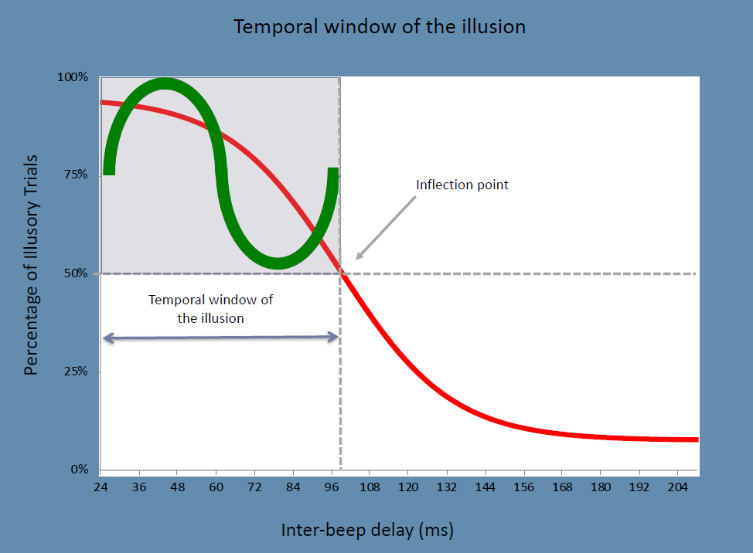Smaller alpha cycle amplitude 🡪 shorter inflection point 🡪 faster alpha frequency 🡪 shorter temporal window of the illusion
  + So, can we manipulate the variable related to the inflection point? Can we find a causational relationship? This is what is done in the second point of the experiment. The first point only served as a method to find the ***Individual Alpha Frequency*** (IAF) on which we can work.

1. In this second point researcher tried to find how we can maximize or minimize the temporal window, considering our IAF, to be more or less prone to perceive the illusion.

* Usually, to induce synchronization of the brain activity with pulses, is used the TMS technique. Here, we cannot use TMS because the click on the TMS can cause the loose of the illusion because our brain elaborates the click has a sound to integrate and elaborate. So, to do not interfere with the auditory/visual percept, tACS is used (which is a method of application of tES).
* To avoid this side effect, each participant was subjected to three sessions of ***tACS* (*transcranial alternating current stimulation*)**, respectively at frequency $IAF-2Hz$, $IAF$ and $IAF+2Hz$, in order to entrain their brain oscillations and see how this entrainment would reflect on their ability to respond to the task.
* We can see how we could *modulate the inflection point* (physiological variable) according to the frequency of the external stimulation which is used.

**Results**

* + results shown that when entraining to a frequency higher than the *Individual Alpha Frequency*, namely when ***increasing the frequency of the alpha waves***, participants were less prone to get fooled by the illusion as result of the ***reduction of*** the length of the ***integration time-window***, on the other hand, an entrainment to a lower frequency with respect to the *IAF* enlarged the temporal window of the illusion, resulting in a lower accuracy.
  + ***Faster alpha frequency 🡪 less perception of illusion 🡪 more precision / accuracy***
  + here is demonstrated that the ***physiological variable*** modulates our wat to perceive the sensations.
  + in conclusion, we can say that the brain builds up the ***best sensory representation within its physiological constraints***, and these constrains can be measured in the form of alpha oscillations, which represent the temporal unit of sensory processing within the visual system and could serve as a cortical scanning mechanism that cyclically gates perception

**Relationship with schizotypy/psychiatric conditions**

People who suffer of schizophrenia have a wider temporal window of illusion, so they have a big slowdown of alpha frequency; this tell us that is the mechanism of integration of information across the senses fails, this can lead to a wrong interpretation of incoming sensory information producing a lot of consecutive illusions which led to hallucinations.